CS437 Assignment 1

**Task 6 : Turkish University advice website honeypot**

Yağız Gürdamar 22534

Berkant Kartop 28046

Cenk Şire 28075

ScreenShots of Web App:

Home:

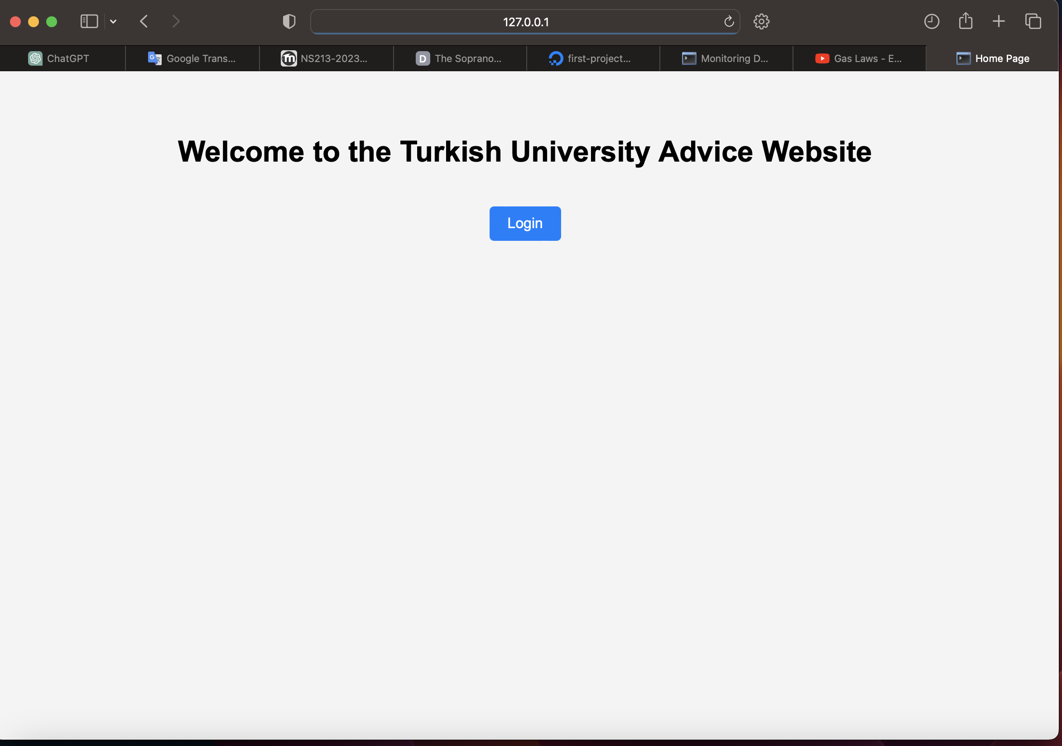

Add Comment Page:

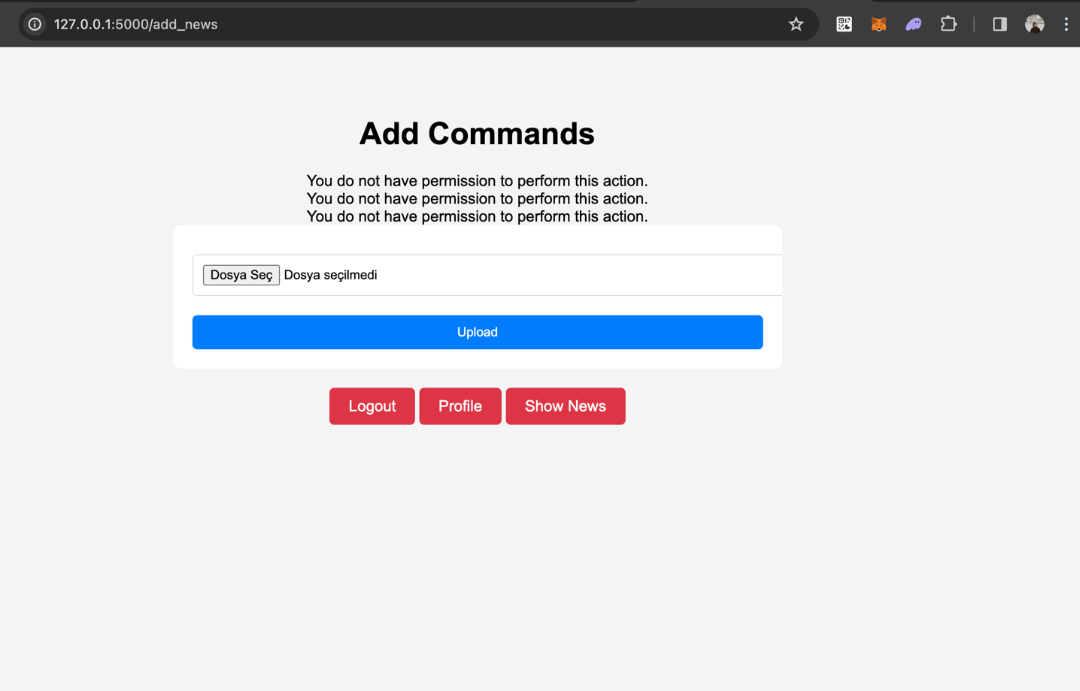

User Profile:

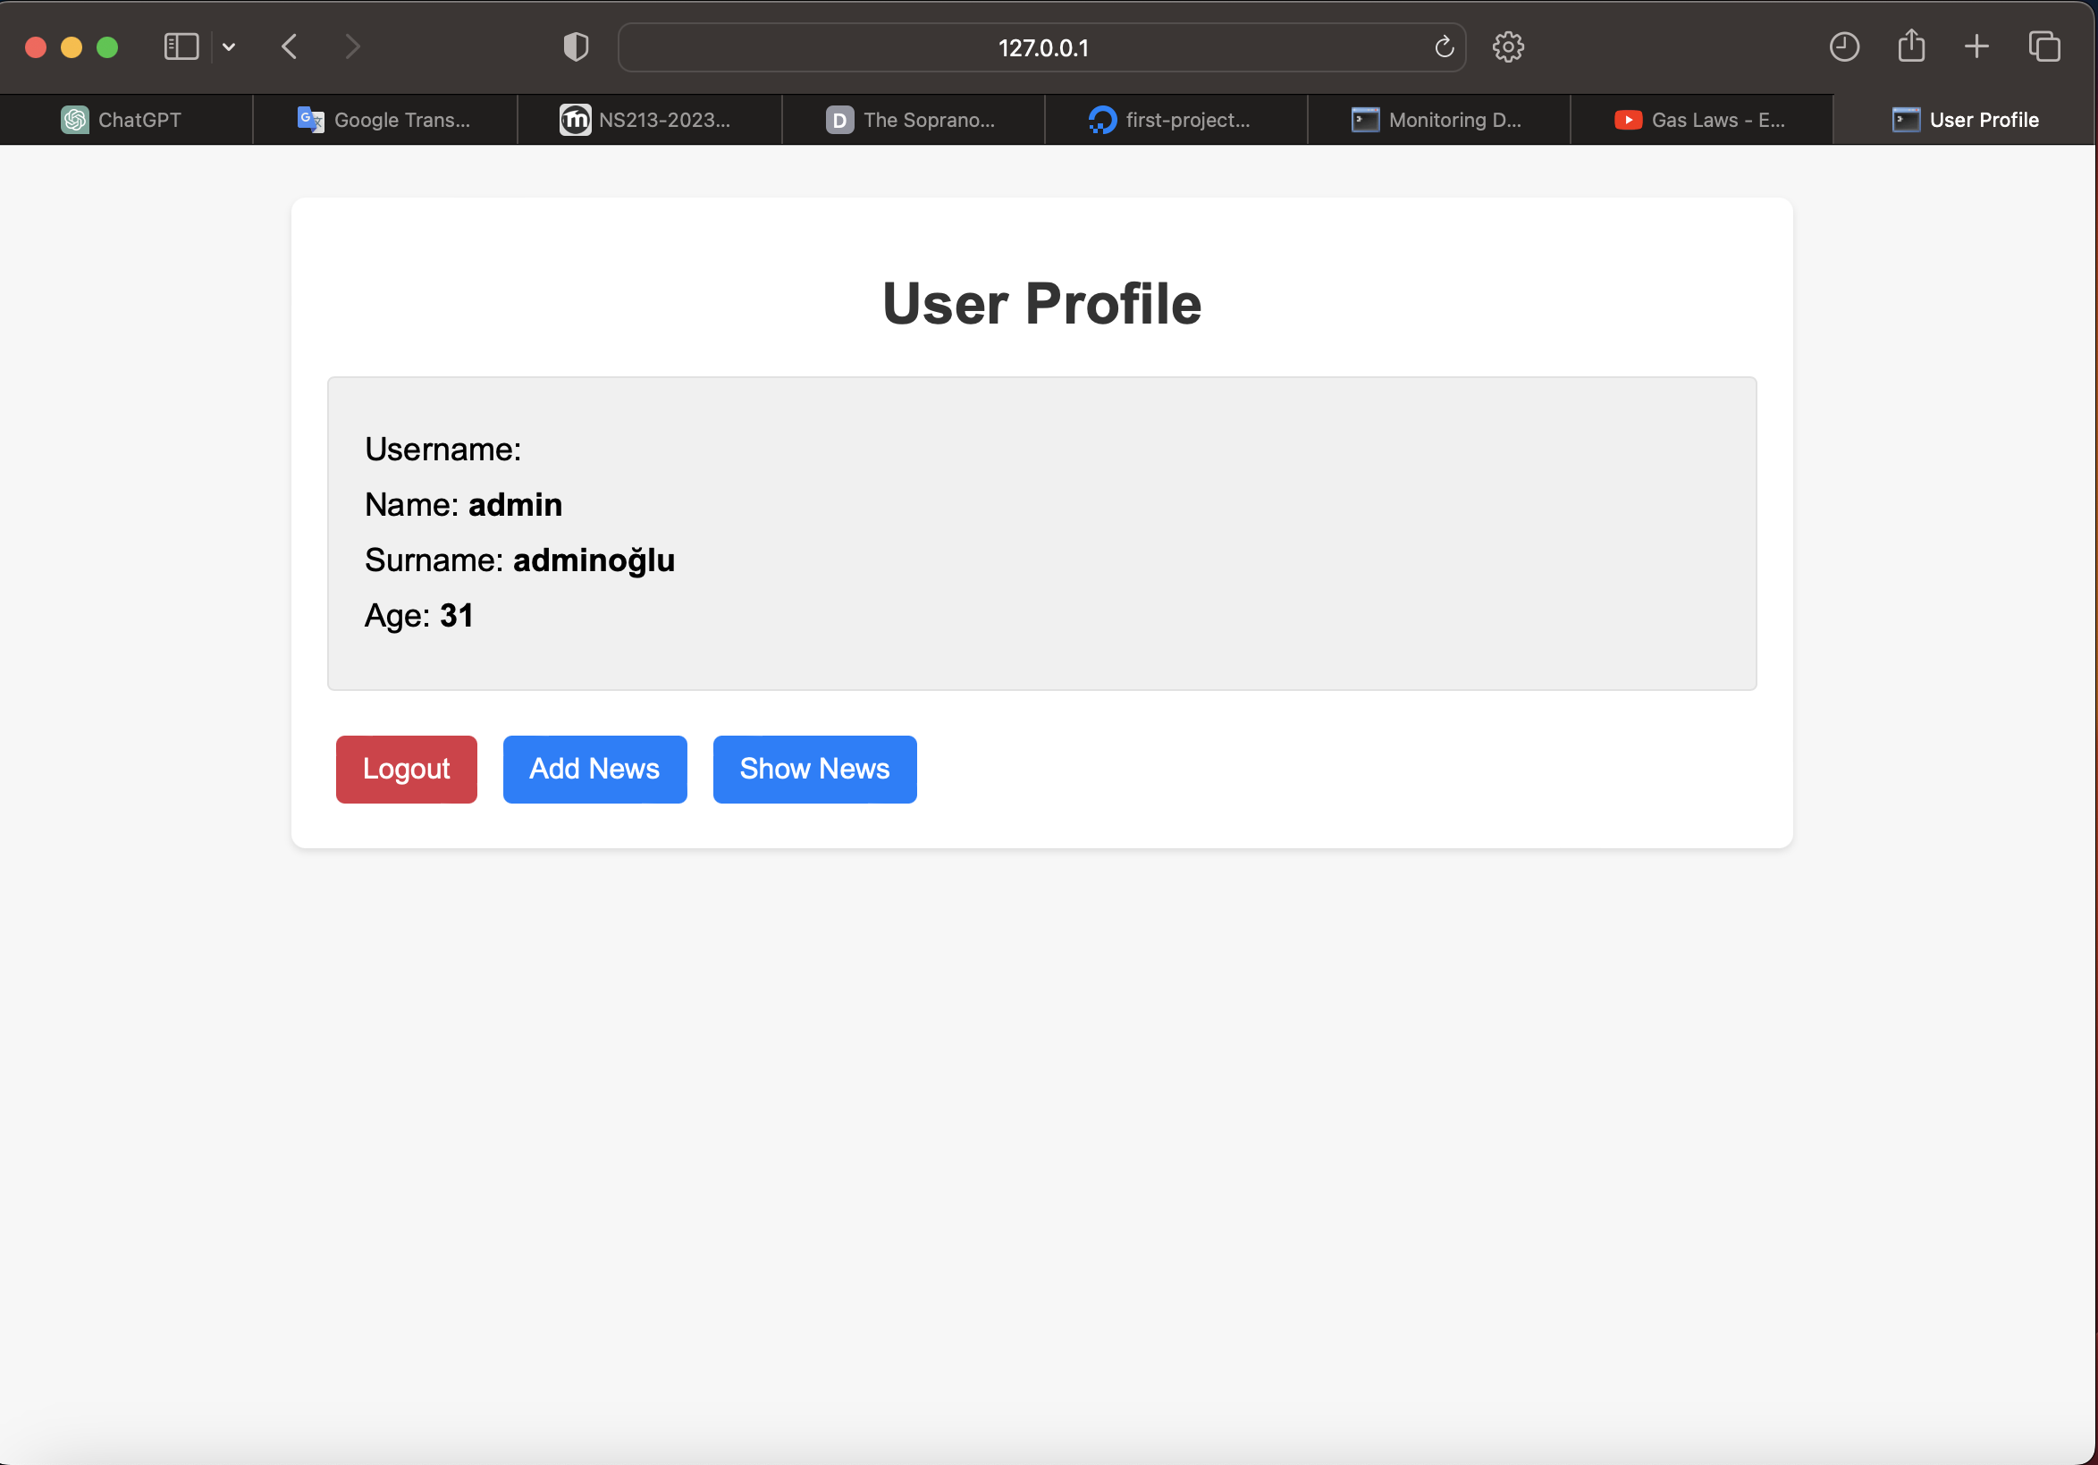

News From RSS Links:

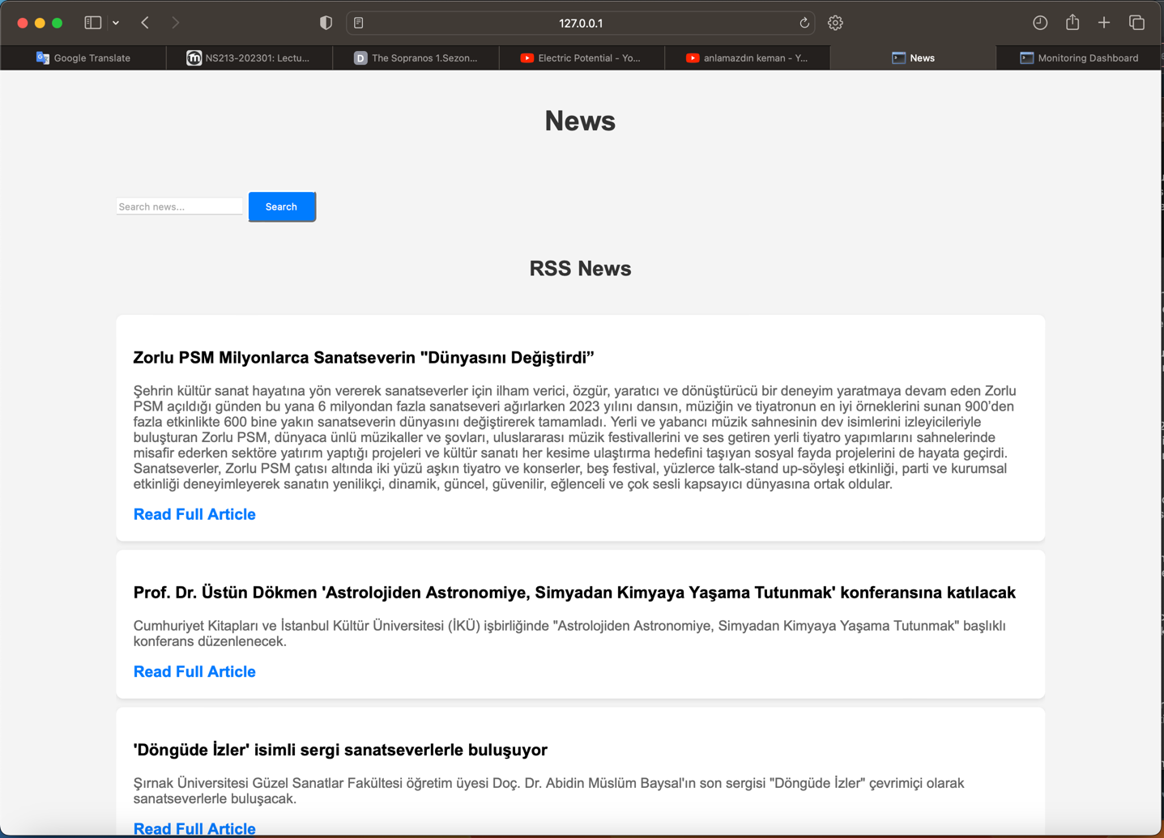

Also in same page(/news) we can uploaded XML content:

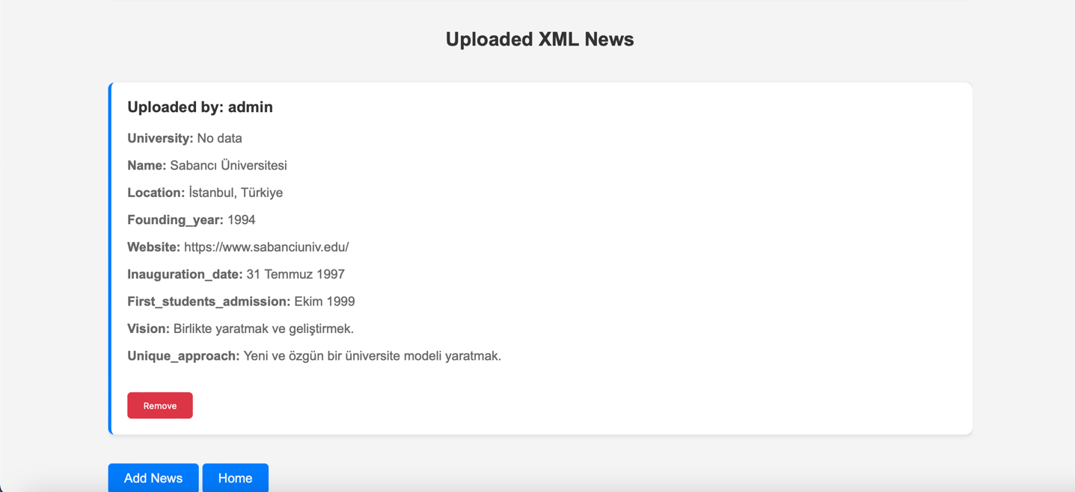

Monitoring Dashboard:

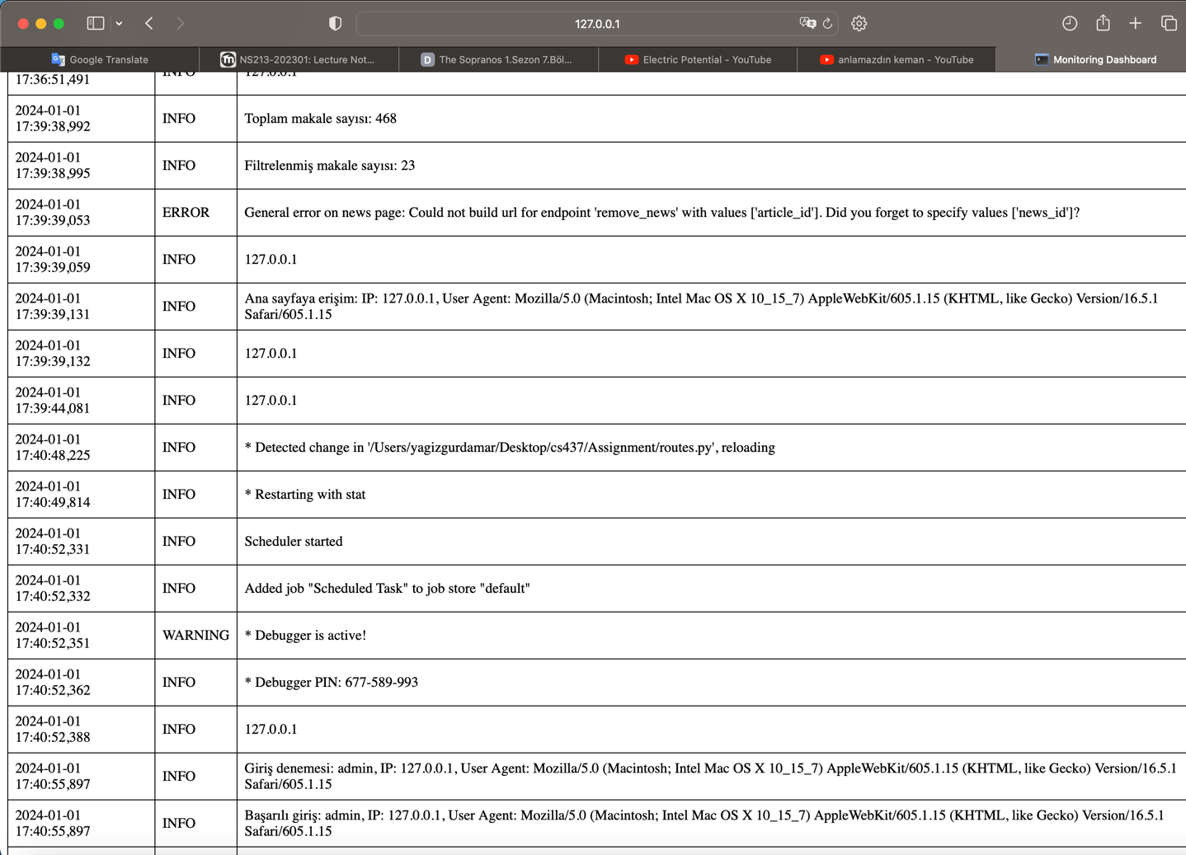

**Introduction:**

This report presents an analysis of the provided web application code, focusing on identifying and explaining various security vulnerabilities and misconfigurations. The application is developed using Python with Flask framework and incorporates functionalities like user registration, login, news feed parsing, and profile management.

**Code Overview:**

- routes.py: Handles the routing of the application and defines the logic for user authentication, news addition, and profile management.

- models.py: Defines the User and Article models using SQLAlchemy ORM for database interactions.

- func.py: Contains utility functions for RSS feed parsing and user credential verification.

- app.py: Initializes the Flask application, configurations, database, and routes.

- HTML Files: Represent the user interface for various functionalities like adding news, user login, registration, etc.

**Identified Vulnerabilities:**

1. CWE-315: Cleartext Storage of Sensitive Information in a Cookie

- Location: routes.py

- Explanation: The application manages user sessions without explicitly securing the cookie where session information is stored. Flask's default session management mechanism stores session data in a client-side cookie in an unencrypted format, making it susceptible to unauthorized access and tampering.

- Impact: Attackers can intercept or manipulate the session cookie to impersonate users or steal sensitive information.

- Mitigation: We can use server-side session management or employ Flask extensions like Flask-Session to store session data securely. Also, use the `secure` and `httponly` flags for cookies to add an extra layer of protection.

2. Failure: XML External Entities (XXE) vulnerability in API

- Location: routes.py (parse_xml function)

- Explanation: The application parses XML input using the ElementTree library without disabling external entity processing. This misconfiguration allows an attacker to craft malicious XML data that can include external entities leading to XXE attacks.

- Impact: XXE attacks can lead to data exfiltration, server-side request forgery (SSRF), or denial of service.

- Mitigation: We can use a safer XML parser or library configured to disallow external entities. For ElementTree, explicitly disable external entity processing.

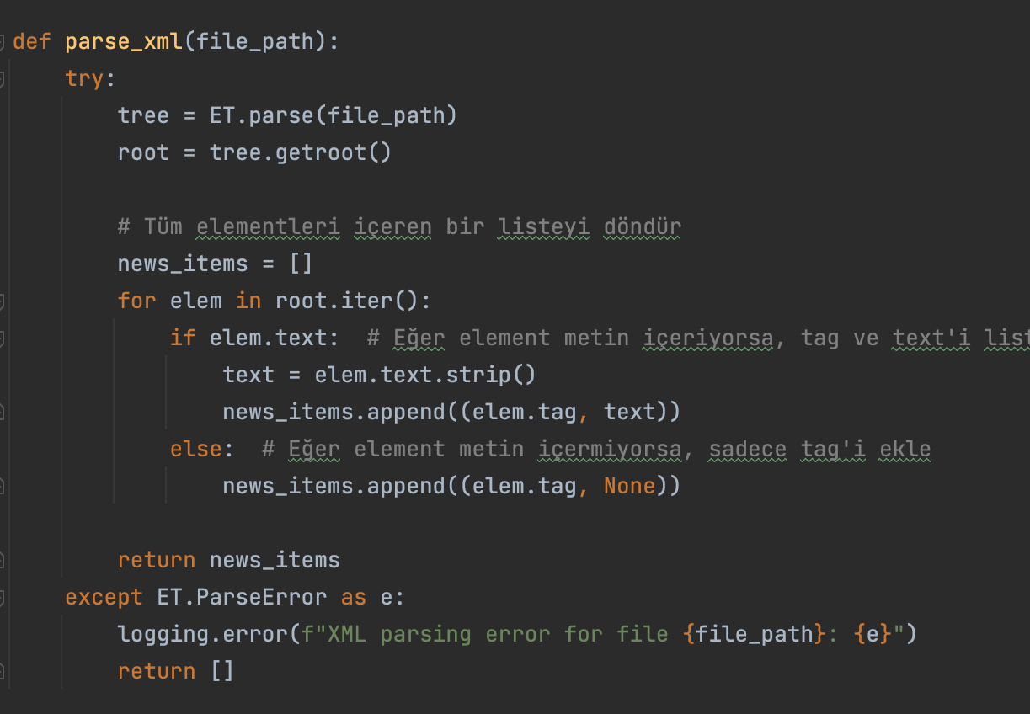

3. SQL Injection via User Input

- Location: routes.py (login and register routes)

- Explanation: The application constructs SQL queries directly using user-provided input without proper sanitization or parameterization, making it susceptible to SQL injection attacks.

- Impact: Attackers can execute arbitrary SQL commands leading to unauthorized data access, data manipulation, or even database structure compromise.

- Mitigation: We can use ORM's parameterized queries feature or employ proper input validation and sanitization techniques.

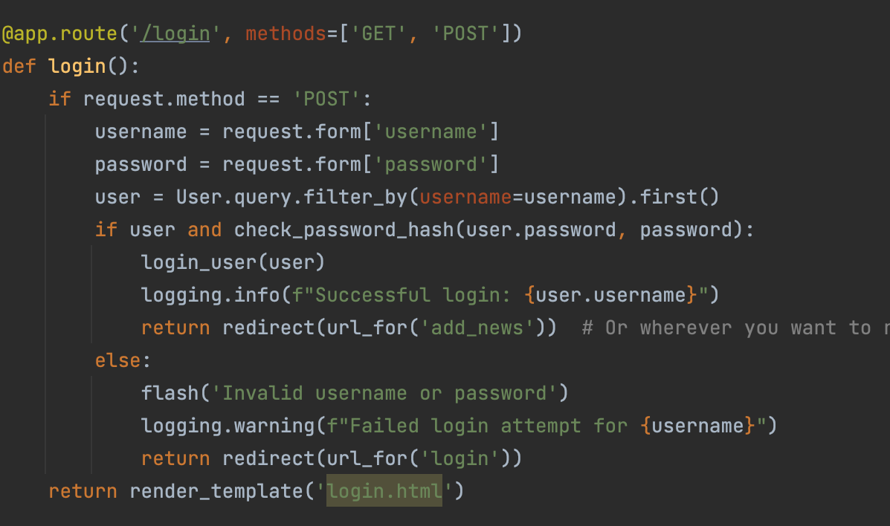

4. Insecure Direct Object References (IDOR)

- Location: routes.py (remove_news function)

- Explanation: The application allows users to delete news articles by submitting a direct request with the article ID. There is no proper authorization check to ensure that the user has the right to delete the specific article.

- Impact: Unauthorized users can manipulate or delete data they shouldn't have access to.

- Mitigation: We may implement robust access control checks to ensure users can only perform actions on resources they own or have explicit permissions for.

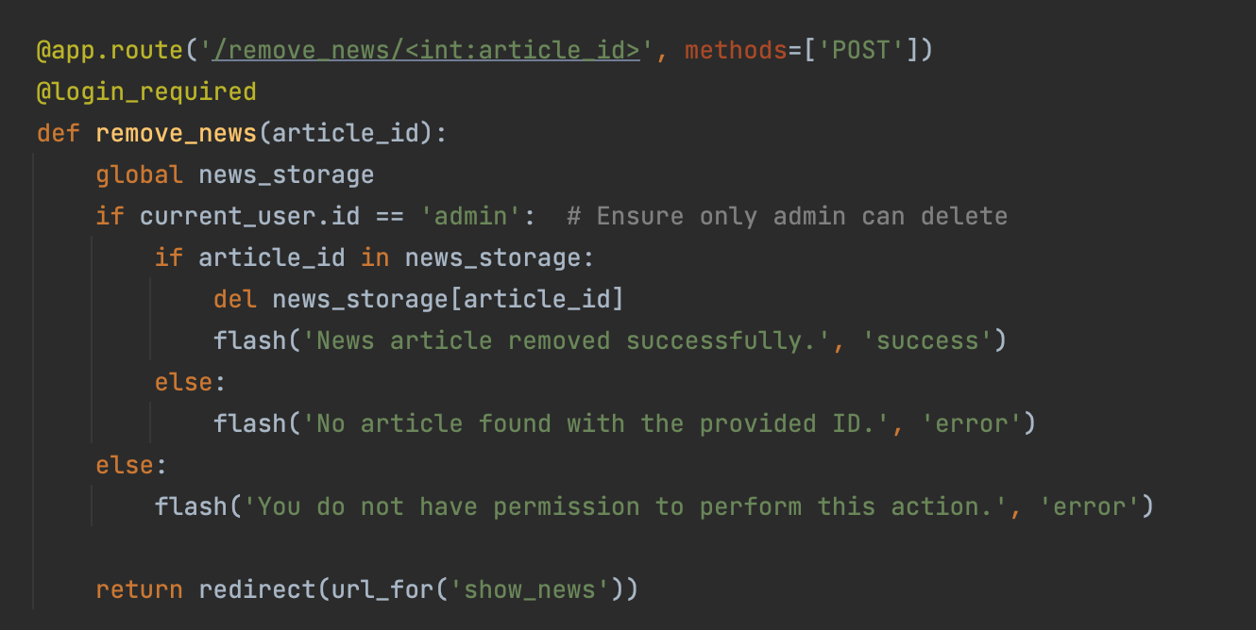

5. Insufficient Logging and Monitoring

- Location: Throughout the application

- Explanation: While the application does some logging, it lacks detailed logging for security-relevant events, and there is no mechanism for real-time alerting or monitoring of suspicious activities.

- Impact: In the event of an attack, the lack of detailed logs and monitoring can hinder the timely detection and response to security incidents.

- Mitigation: Implement comprehensive logging of security-relevant events and integrate with a monitoring system that can provide real-time alerts and analysis.

6. Hardcoded Sensitive Information

- Location: func.py (check_user_credentials function)

- Explanation: The application contains hardcoded credentials within the codebase. This practice is insecure as it exposes sensitive information in the code.

- Impact: If the codebase is exposed, attackers can easily find and misuse hardcoded credentials.

- Mitigation: We might store sensitive information like credentials in environment variables or secure configuration files.

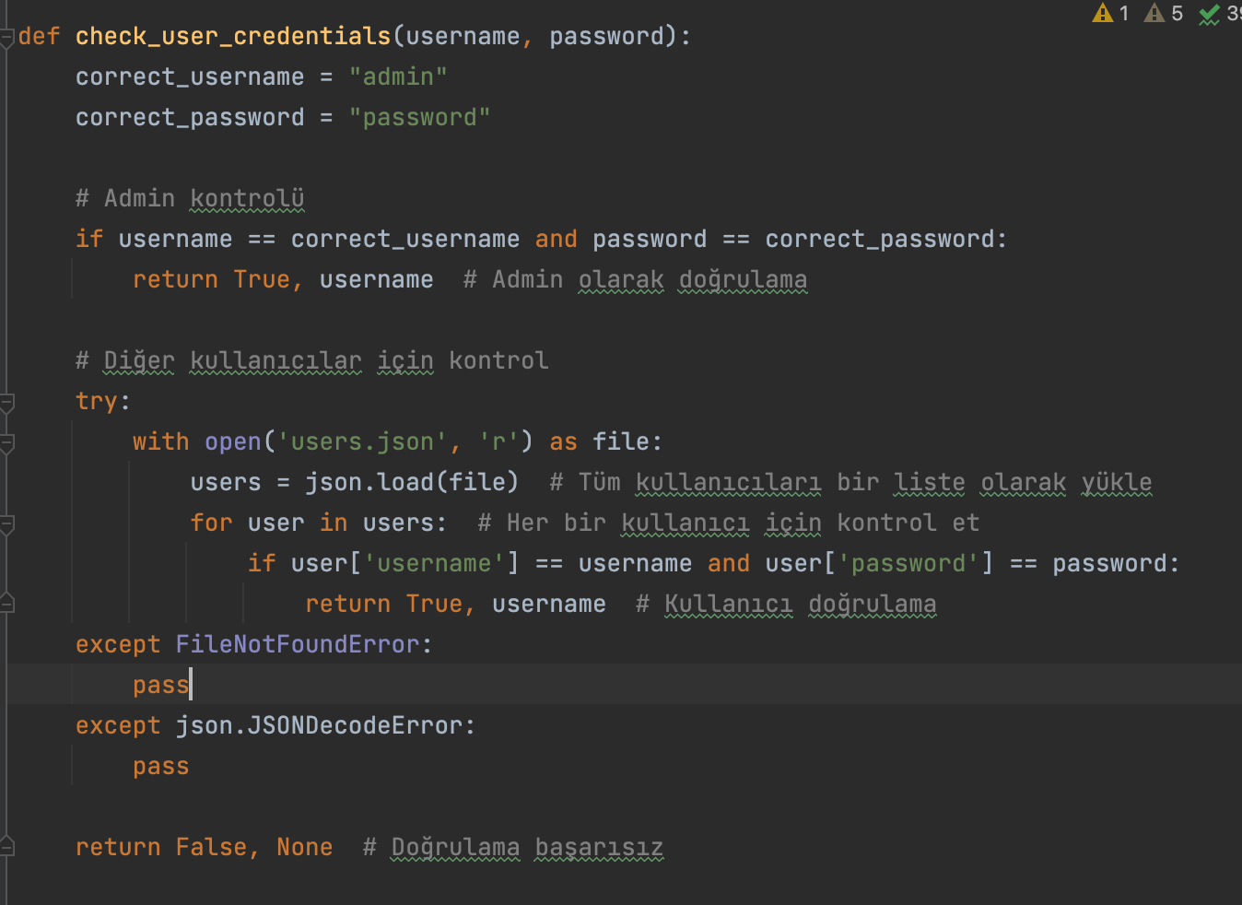

**How to Demonstrate Vulnerabilities:**

**Conclusion:**

The identified vulnerabilities and misconfigurations represent significant security risks. It's crucial to address these issues by implementing the suggested mitigation strategies. Additionally, adopting a secure coding practice and regular security audits can further enhance the application's security posture.

**Testing:**

**Flake8:**

* **OS:** Windows
* **Findings:**

○ F401: Unused Imports - Multiple instances of modules or objects imported but not used, leading to namespace bloat.

○ F811: Redefinition of Unused Variables - Variables redefined without being used, indicating poor code maintenance.

○ E302 & E305: Spacing Issues - Incorrect number of blank lines around functions or class definitions, violating PEP 8 style guidelines.

○ E501: Line Length - Lines of code exceeding the recommended length of 79 characters, affecting readability and maintenance.

○ E231: Whitespace Issues - Missing whitespace after commas, a style issue.

○ E122 & E131: Indentation Issues - Improper indentation for continuation lines, impacting code readability.

○ W391: Blank Line at End of File - Unnecessary blank line at the file's end.

* **Conclusion:**

The flake8 tool primarily focuses on code quality and adherence to PEP 8 style guidelines, rather than directly identifying security vulnerabilities. While these issues, such as unused imports, redefinition of variables, spacing, line length, whitespace, and indentation issues, do not represent direct security risks, they can indirectly impact the overall security posture by affecting code clarity and maintainability.

* **Screenshots:**

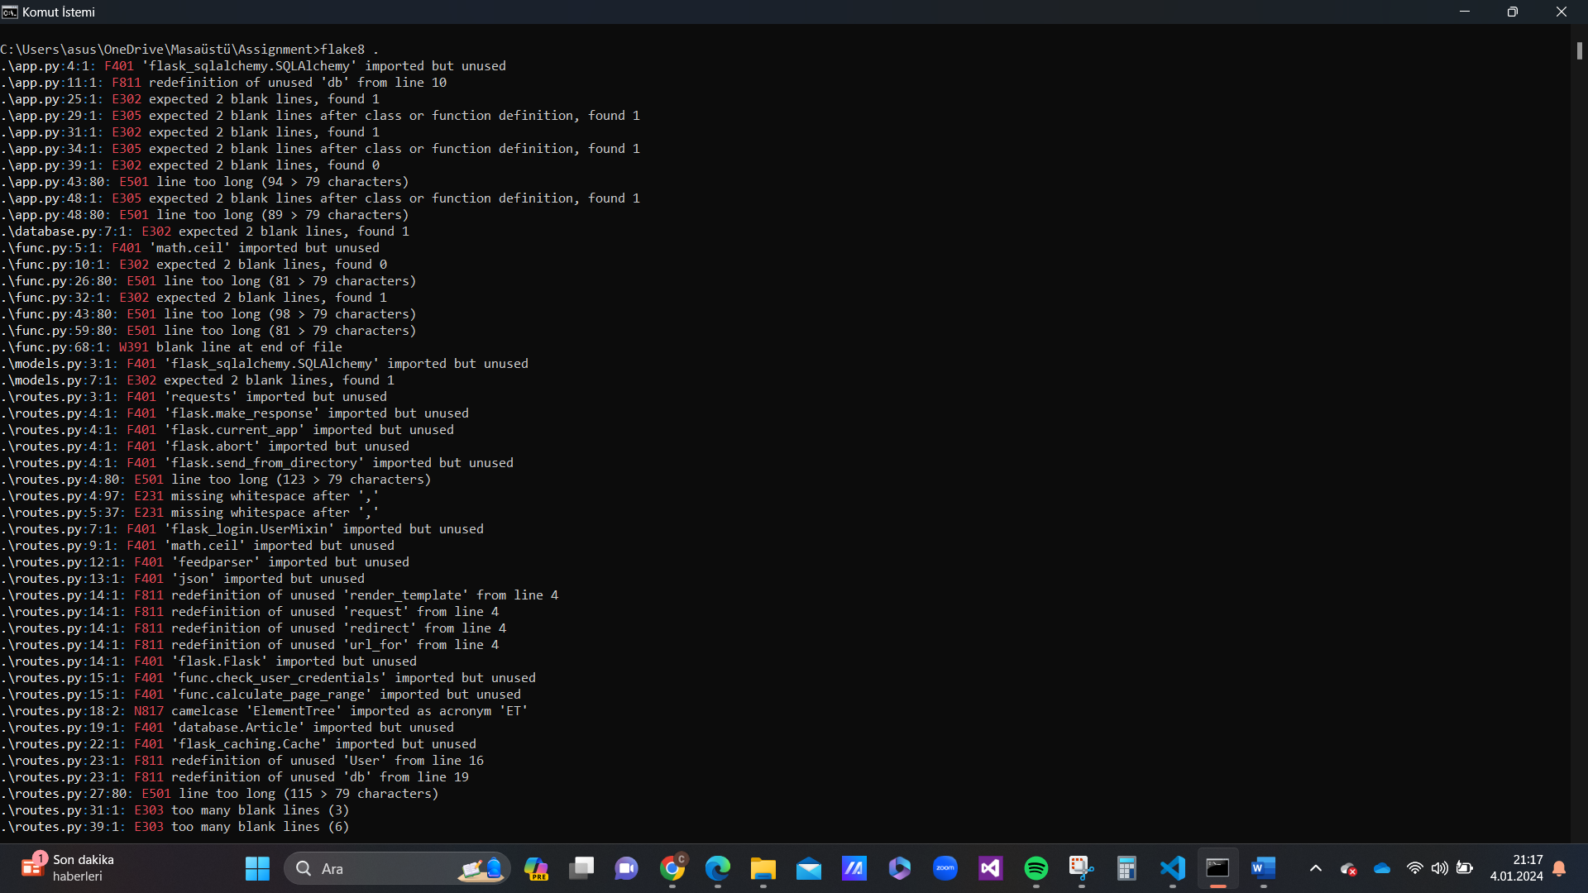

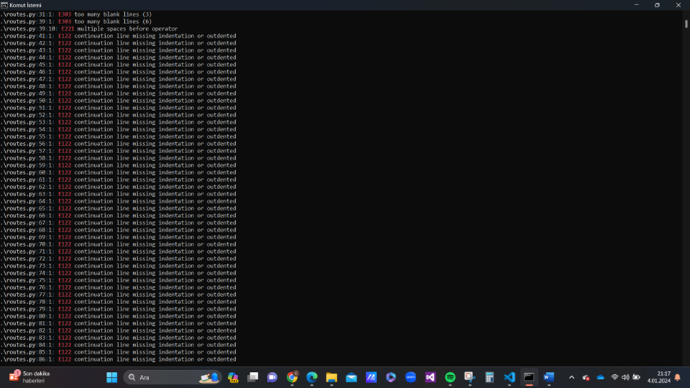

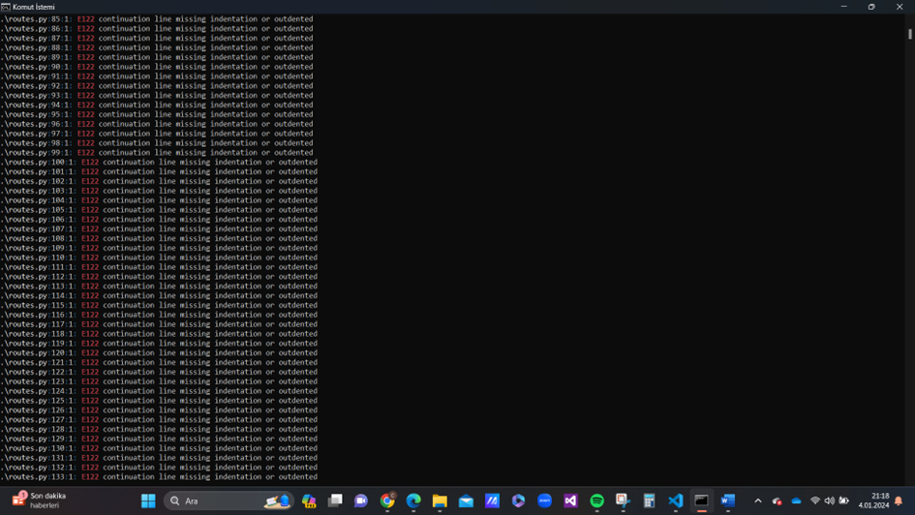

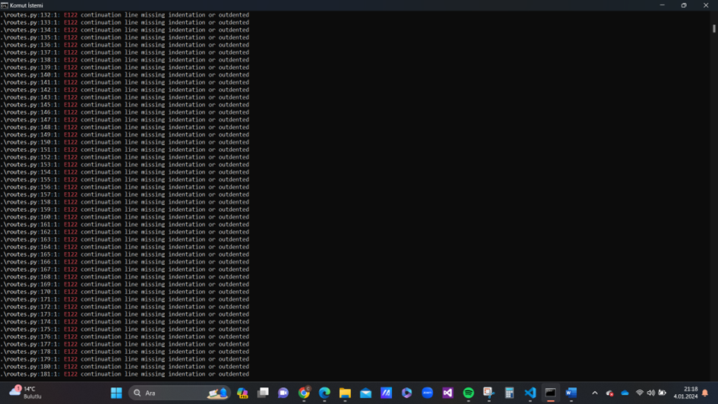

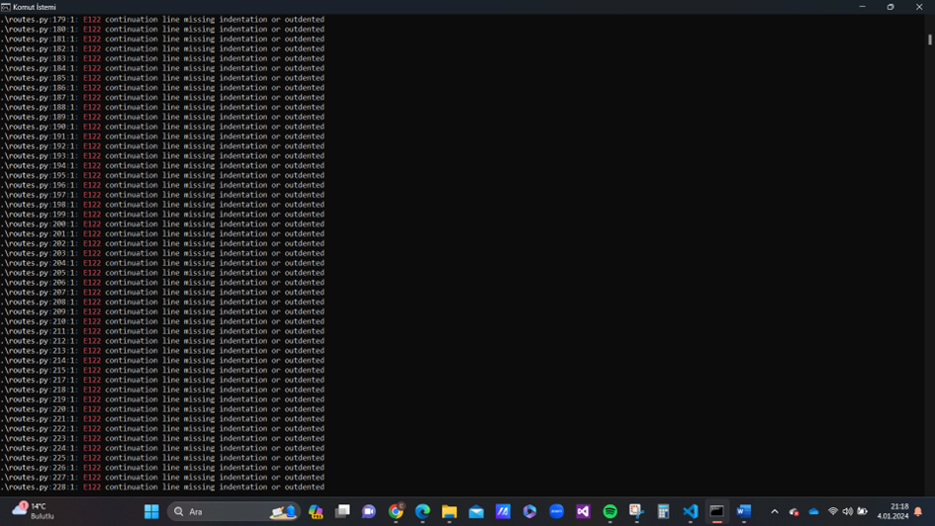

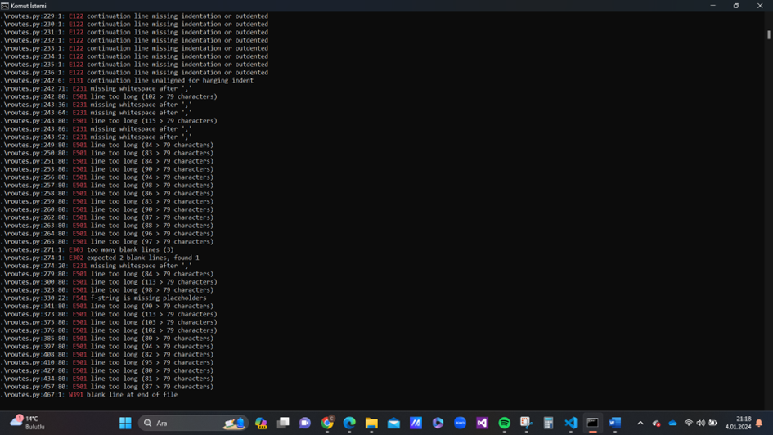

**Bandit:**

* **OS:** Windows
* **Findings:** 
  + B105: Hardcoded Password String
  + B201: Flask Debug True
  + B410 & B405: Using etree and ElementTree to Parse Untrusted XML Data
  + B314: Using xml.etree.ElementTree.parse
* **Conclusion:**

It can be said that the bandit is capable of finding vulnerabilities in a python code partially successfully, but not completely since the target vulnerabilities of the chosen task were, CWE-315 Cleartext Storage of Sensitive Information in a Cookie & XML External Entities (XXE) vulnerability in API Failure. It is capable of detecting parsation of an untrusted XML data, However, it does not seem to have detected the cleartext storage of sensitive information in a cookie (CWE-315).

Bandit was really easy to install and use. Documentation wirtten by the owners was clear. Results were listed separately which makes them easier to understand.

* **Screenshots:**

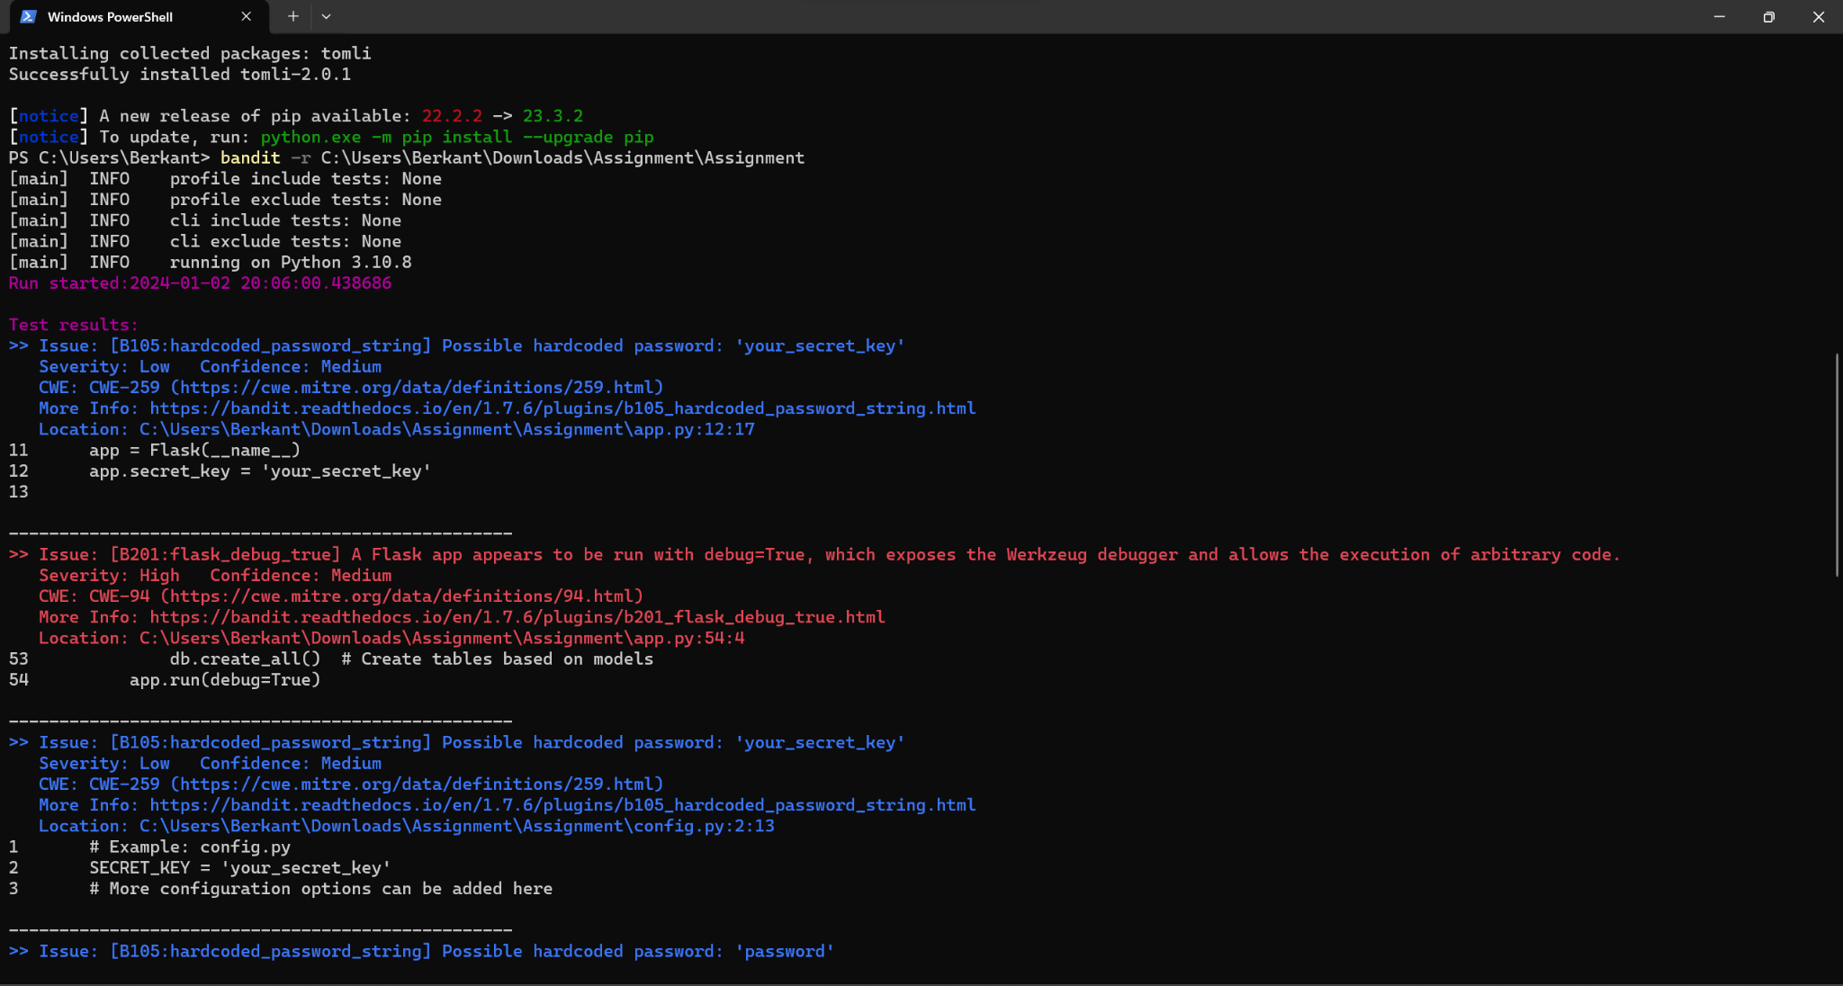

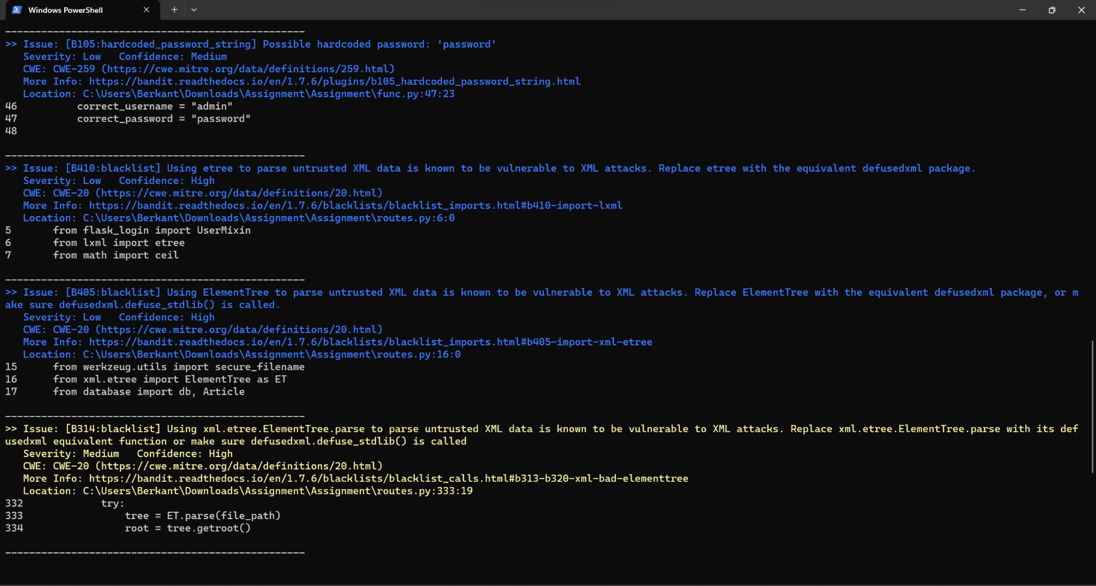

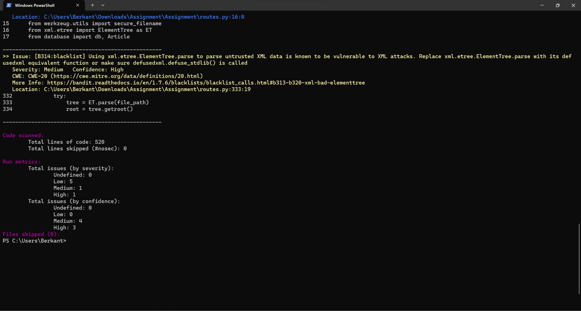

**Prospector:**

* **OS:** Windows
* **Findings:**
  + Beside the “Hardcoded Secret Key Warning” most of the outcome that prospector give is, factors that related to complexity or efficiency of the code such as, unused imports, re-imported modules, etc.
* **Conclusion:** 
  + The finding that mentions “Hardcoded Secret Key Warning” is related to CWE-315 due to usage of the secret key for cookie encryption, but still it is not offering any findings on XXE.
  + Even if the prospector can be beneficial for improving a project make it more secure and efficient, it would be better to use different analyser in order to detect CWE-315 and XXE vulnurabilities.
  + Installation and usage process of the Prospector was easy. The main problem was results were listed as line by line rather than catagorized as topics, so repeated sentences and finding can occur.

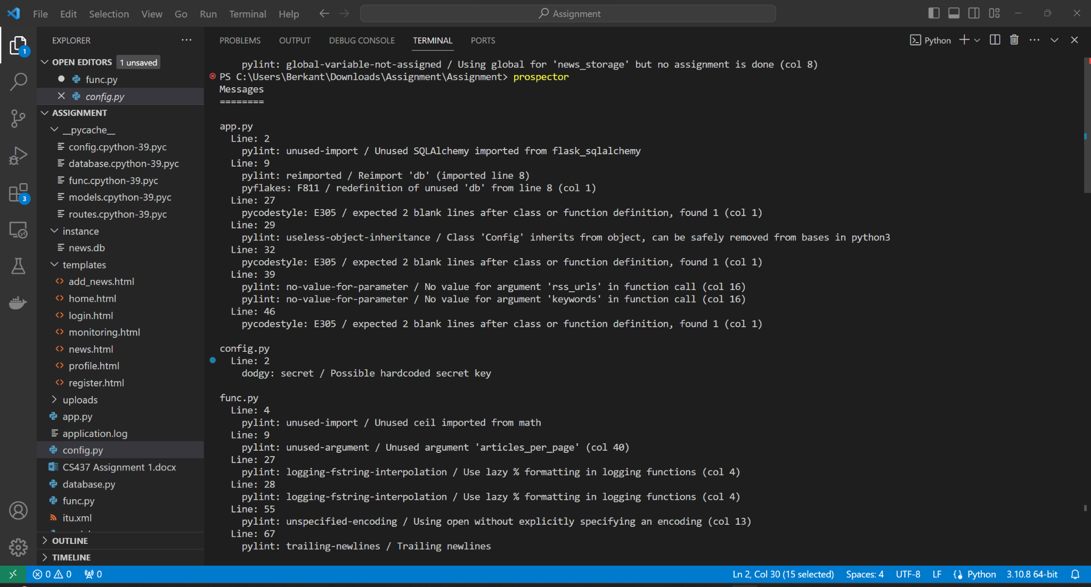



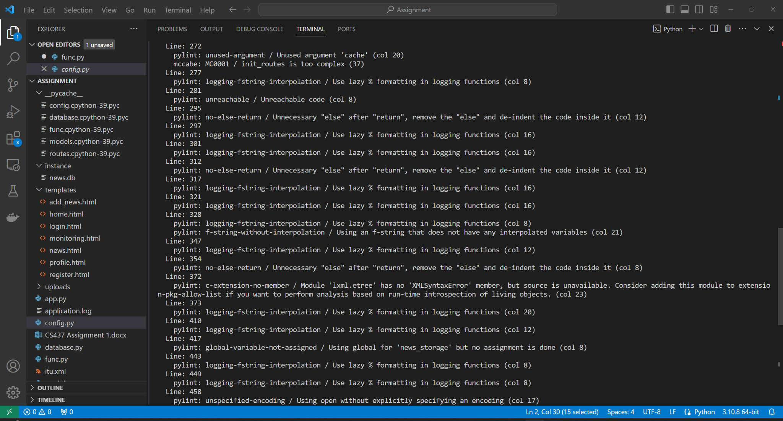

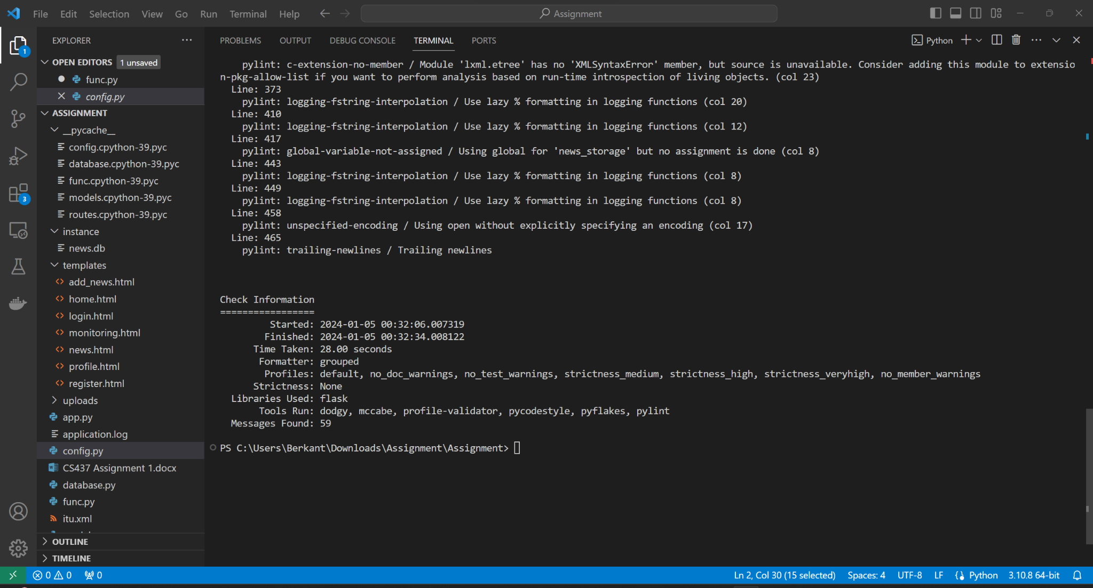

**RATS(Rough-Auditing-Tool-for-Security):**

* **OS:** Linux (Since the RATS is a tool that mainly designed for Linux, it hass been decided to conduct the tests with RATS on Linux.)
* **Findings:** 
  + Bad Token
  + File not Found
  + Duration of the analyse
* **Conclusion:**
  + Eventhough RATS offers different, results such as duration for timeout measurements and more, but It was not capable of bringing up findings that are related to CWE-315 & XXE. So It would be better to move on with a different analyser for this task.
  + Installation and usage process of RATS was easy, but it should be mentioned in the documentation that the easiest way to use the program is, using it on a LINUX operated system.
* **Screenshots:**

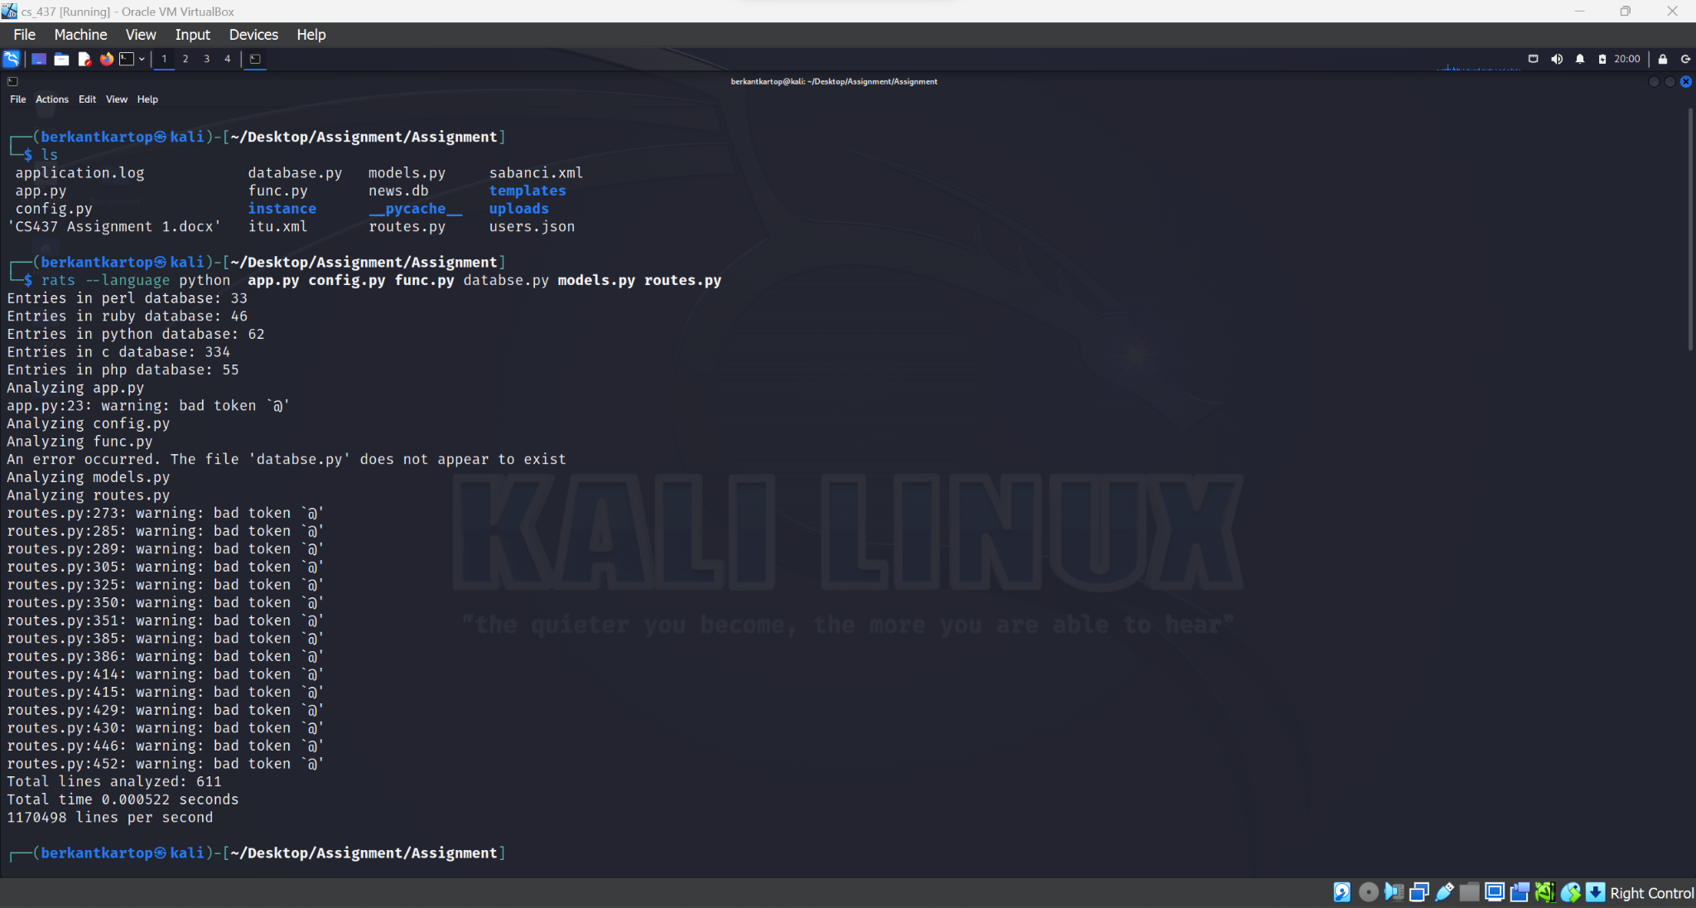

**PYT (Python Taint):**

* **OS:** Windows
* **Findings:**
  + Analyse made by PYT resulted as ”No vulnerabilities found.” throughout the whole project or made it scan python files one by one.
* **Conclusion:** 
  + It can be concluded that the PYT(python-taint) did not work properly, since it is already known that project contains some vulnerabilities. So it can be said that the results given by PYT are not correct, another code analyser would be more propriate for the project.
  + Installation and usage of the program was challenging due to lack of information with the documentation and the program is not appropriate to use with latet versions of the required programs, versions of the programs should be rearrenged to make the program functioning.
* **Screenshots:**

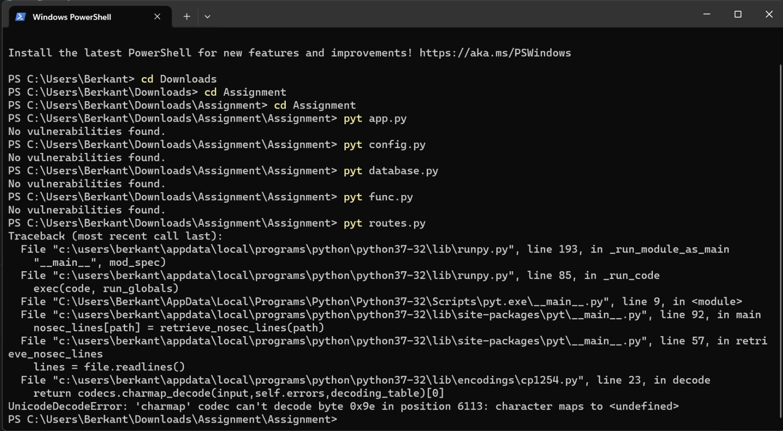

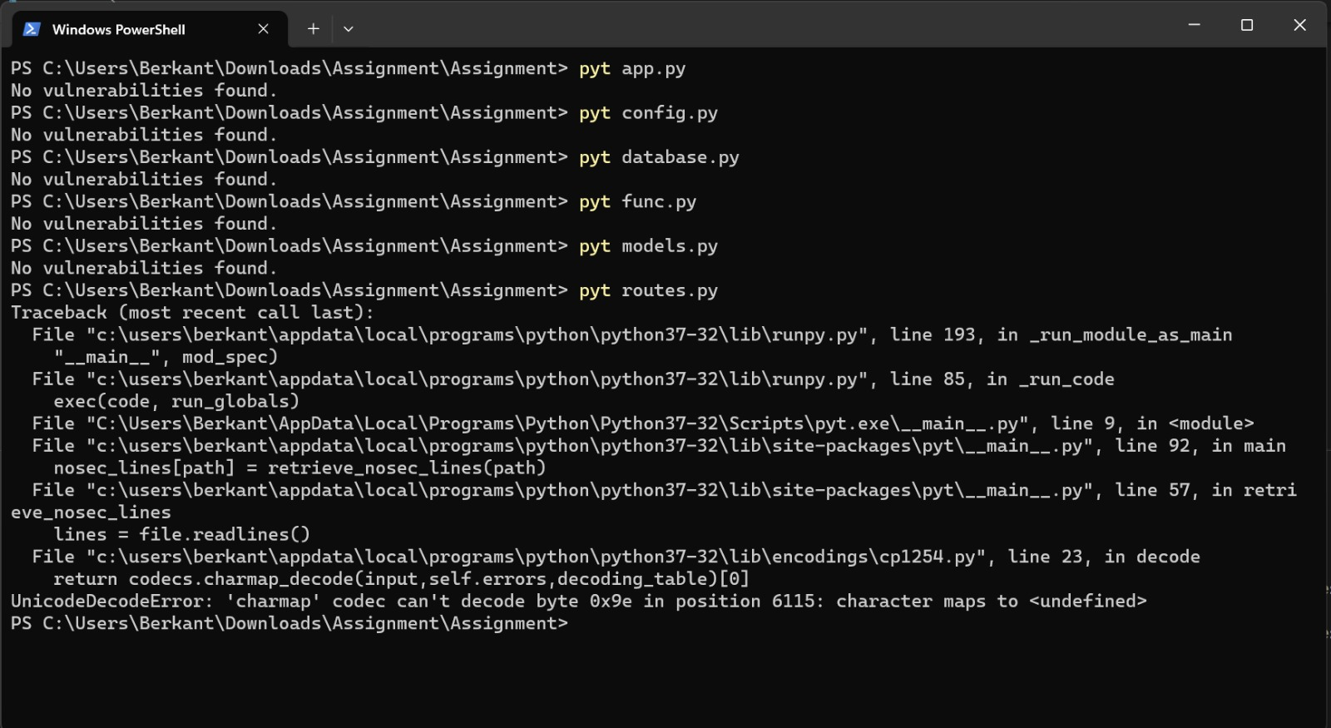

**Roles and Responsibilities:**

Yağız: Developed the entire codebase for the Flask application, including routes, user authentication, database interactions, and XML parsing functionalities.

Integrated basic security measures and intentionally introduced vulnerabilities for demonstration purposes and documented the code and provided comments for clarity and future reference.

Berkant: I installed the mentioned tools and run the source code in the given tools, Analysed the results provided by the tools. Then I inspected the results and decided wether the tool and given result approiorate for finding the vulnerability that we implemented. I mentioned whether the tool is suitible for finding the searched vulnerability and reported them. I also commented on whether the given tool is easy to install and use or not. Finally after the functioning project developped by Yağız, I tried to fix some bugs and misfunctionings.

Cenk: In the project, in addition to the given static code analysis tools for Python - Bandit, PYT (Python Taint), Rough-Auditing-Tool-for-Security, and Prospector - I independently identified and tested the Flake8 tool. This involved analyzing our Python codebase with Flake8 to detect the vulnerability. I installed the tool, made the analysis and gave an explanation about the anlysis.